Name: Key

Lab 4 - Soils

Due at the beginning of the next lab. All students must submit their own work.

Web Soil Survey

Click on the “Lab 4 – Soil Survey” hyperlink in Canvas, Module Week 5. Open the link in a new tab. Click on the green button that says “Start WSS”. Using the pan and zoom tools in the interactive map, locate the UIUC main quad. Click the “Define AOI by rectangle” tool and delineate an AOI (area of interest) around the main quad. Have your AOI span from Wright St. to Mathews Ave, and from Green St. to just south of Foellinger Auditorium. Your AOI should look like the one in the figure below.

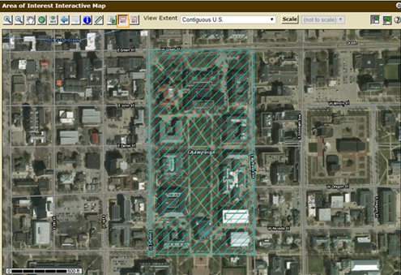

- Above the interactive map, click on the tab “Soil Data Explorer”, and on the tab menu that appears below that click on “Soil Properties and Qualities”. Make sure that your AOI is still selected. Under the “Properties and Qualities Ratings” menu on the left, click on “Soil Physical Properties” and then “Organic Matter”. Leave all of the default settings as they are, except at the bottom check the option “All layers (weighted average)”. Then click “View rating”. Fill in the blank spaces in the table on the next page:

Map unit symbol | Map unit name  (ignore percent slopes) | Rating (percent)
152A | Drummer silty clay loam | 1.89
154A | Flanagan silt loam | 1.43
171B | Catlin silt loam | 1.34

Which soil has the highest percentage of organic matter? (This is our state soil)

Drummer silty clay loam

Soils are commonly classified based on their particle size distribution. Sand, silt, and clay are the three broad particle classes. The USDA defines them as follows: Clay particle diameter is less than 0.002 mm, silt particle diameter = 0.002-0.05 mm, and sand particle diameter is greater than 0.05 mm. While there are more specific subcategories, we’ll only deal with these three broad categories in this lab.

2.(a) Now click “Percent Clay” in the menu on the left and again leave all of the default settings except check “All layers (weighted average)”. Then click “View rating”. Fill out the table below:

Clay
Map unit symbol | Map unit name  (ignore percent slopes) | Rating (percent)
152A | Drummer silty clay loam | 28.1
154A | Flanagan silt loam | 28.7
171B | Catlin silt loam | 30.1

2.(b) Do the same as question 2 but for “Percent Sand”. Fill out the table below:

Sand
Map unit symbol | Map unit name  (ignore percent slopes) | Rating (percent)
152A | Drummer silty clay loam | 19.3
154A | Flanagan silt loam | 12.9
171B | Catlin silt loam | 12.4
2.(c) Do the same as above but for “Percent Silt”. Fill out the table below:

Silt
Map unit symbol | Map unit name | Rating (percent)
152A | Drummer silty clay loam | 52.5
154A | Flanagan silt loam | 58.4
171B | Catlin silt loam | 57.5

3. Plot the three soil units from above on the USDA soil texture diagram below. Reference the clay, sand, and silt compositions to complete this. Label the units on the diagram with the first letter of their respective map unit name (i.e., D, F, or C).

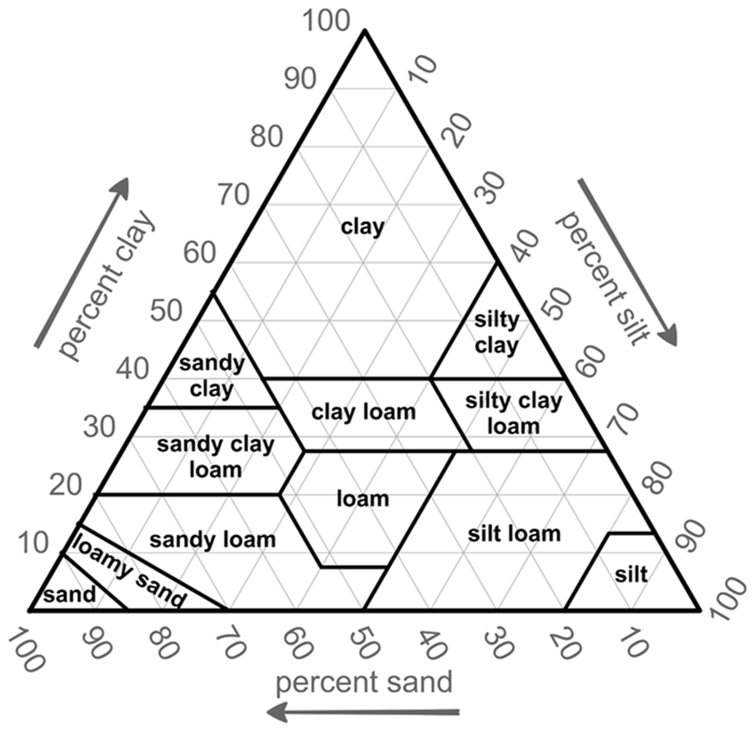
D
F
C

4. Switch to the “Suitability and Limitations for Use” tab. Click on “Vegetative Productivity”, then click on “Yields of Non-Irrigated Crops (Component)”. Make sure the crop is set to corn and then click “View Rating”. The rating displayed indicated crop yield in bushels per acre. All three of the soil types present on the quad have a high yield index, but which has the best? (Circle one)

Drummer silty clay loam Flanagan silt loam Catlin silt loam

5. Now click on the “Soil Map” in the upper row of tabs. Then click on the soil name that you chose for the previous question. In the window that appears, use the “Typical Profile” section to fill out horizon information for the soil you chose. (Horizon = soil layer name. Horizons make up a soil profile.)

Horizon | Depth (inches) | Textural Class
Ap | 0-14 | Silty clay loam
Btg | 14-41 | Silty clay loam
2Btg | 41-47 | Loam
2Cg | 47-60 | Stratified sandy loam to clay loam

6. According to where the soil units are plotted in Question 3, are their names accurate? For example, is the Drummer Silty Clay Loam actually a silty clay loam? If not, speculate why using the table in Question 5?

Drummer has the accurate name, but flanagan and catlin do not. Maybe because they are silty clay loam at the surface but more like silt loam at different depths.

7. Climatic variables like precipitation and temperature are major drivers of soil formation processes. In the map unit description report window for the soil that you chose for question 4, locate and record the “Mean annual precipitation” and the “Mean annual air temperature” for the soil (under the Map Unit Setting section at the top).

Mean annual air temperature: 46 to 54 Degrees

Mean annual precipitation: 33 to 43 Inches

8. Open the link on Canvas titled “Lab 4 – Champaign Weather Data.” Do the actual average annual rainfall/air temperature measurements fit within/close to the ranges above?

Yes – high temp is close enough

Soils are also classified in a taxonomic system, much like organisms are. The broadest classification for soils is Order. Look at the brief descriptions of the 12 different soil orders below and answer the following questions. (Hint: think about our main landscape ecosystem along with our midwestern climate)
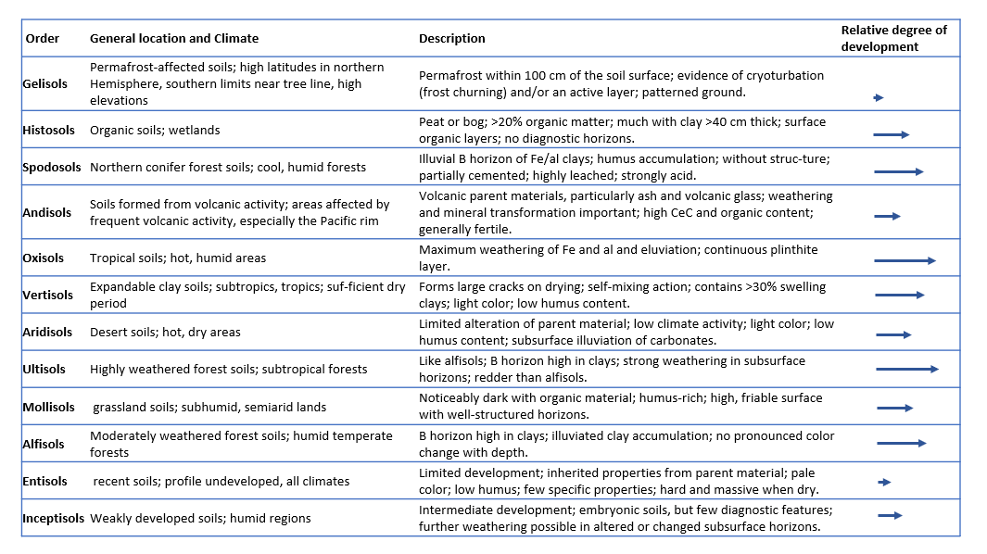

9. Which soil order do you think the soils in our region belong to? Why?

Mollisols – main soil for grasslands

10. Which order of soil would you expect to be most common in the forests of northern Minnesota and Wisconsin? Which order of soil would you expect to be most prevalent in the Cascade Range of the Pacific Northwest? Defend both responses.

Spodosols and Andisols
